ASSIGNMENT 1:CNN DESIGN & GRADIENT-BASED TRAINING
Topics Covered:Convolution, pooling, stride/padding, initialization, CNN training.
Description: Design and train a CNN for an image-classification problem. Compute output shapes and parameter counts for each layer, select suitable initialization and optimizer, apply regularization, and report learning curves and test results.

OBJECTIVE
To design and train a Convolutional Neural Network (CNN) for image classification, calculate the output shape and trainable parameters of each layer, select suitable weight initialization and optimizer settings, apply regularization, and evaluate the model using learning curves and test metrics.

PROBLEM DESCRIPTION
This assignment uses the CIFAR-10 image-classification problem as a representative experiment. CIFAR-10 contains 32 × 32 colour images belonging to ten classes, such as cars, birds, cats, dogs and ships. The CNN learns spatial patterns from labelled images and predicts the class of an unseen image.
Note on results: the architecture calculations below are exact for the stated model. The performance values in the results section are clearly labelled as illustrative reporting values, not as a claim that training was executed on this computer. Replace them with actual output after running the included training code.

TASK 1 – Design the CNN Architecture
The proposed model uses two convolutional blocks followed by a dense classifier. A convolution layer learns local image features, ReLU introduces non-linearity, max pooling reduces spatial dimensions, dropout reduces overfitting, and softmax converts the final logits into class probabilities.
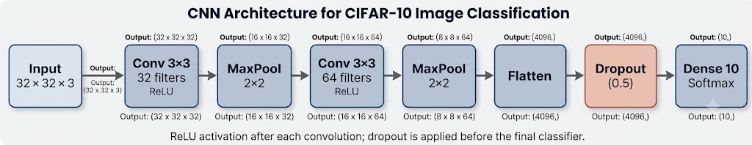

Figure 1. Proposed CNN architecture for CIFAR-10.
Design choices:
The architecture follows a feature-extraction pipeline. Early convolution filters can learn simple edges, corners and colour transitions. Deeper filters combine these patterns into more useful shapes and object parts. Pooling reduces the spatial size of feature maps, allowing later layers to process a more compact representation.
The use of same padding in convolution preserves the height and width when stride is one. This makes the spatial dimensions easier to track and avoids losing border information too quickly. The two pooling operations reduce the 32 × 32 image grid to 16 × 16 and then 8 × 8.
This is a baseline design rather than the only possible CNN. A deeper network may learn more complex features but increases computation and may overfit if regularization and data quantity are insufficient.
- Input: RGB image of shape 32 × 32 × 3.
- Convolution: 3 × 3 kernels, stride 1, padding='same'; ReLU activation.
- Pooling: 2 × 2 max pooling with stride 2 to halve height and width.
- Regularization: dropout with rate 0.30 before the final dense classifier.
- Output: ten neurons with softmax, one for each CIFAR-10 class.

TASK 2 – Identify the Main Operations
The main computational operations are convolution, activation, pooling, matrix multiplication in the dense layer, loss calculation, and gradient-based parameter updates. Convolution is usually the most computationally expensive operation because it applies many filters at every spatial location.
A convolution layer performs multiply-and-accumulate operations between each local input patch and a filter. The number of operations grows with feature-map height, feature-map width, kernel size, input channels and filter count. Dense-layer matrix multiplication is also important, especially because flattening creates 4,096 input features for each of the ten output units.
Pooling compares values within each local window and retains the maximum value. Although pooling has no trainable parameters, it reduces later computation by shrinking the feature maps. During backpropagation, gradients are passed through the network so that the filters and dense weights can be adjusted.
During training, cross-entropy measures prediction error. Backpropagation computes gradients of the loss with respect to weights, and the Adam optimizer uses these gradients to update the parameters.

TASK 3 – Calculate Output Shapes and Parameters
For a convolution or pooling layer, the output dimension is calculated as:
Output = floor((Input − Kernel + 2 × Padding) / Stride) + 1
For a convolution layer, trainable parameters = (kernel height × kernel width × input channels
+ 1 bias) × number of filters.

Layer | Output shape | Trainable  parameters | Calculation
Input | 32 × 32 × 3 | 0 | Input image
Conv2D, 32 filters,  3×3, same | 32 × 32 × 32 | 896 | (3×3×3 + 1) × 32

MaxPooling2D,  2×2 | 16 × 16 × 32 | 0 | Spatial dimensions halved
Conv2D, 64 filters,  3×3, same | 16 × 16 × 64 | 18,496 | (3×3×32 + 1) × 64
MaxPooling2D,  2×2 | 8 × 8 × 64 | 0 | Spatial dimensions halved
Flatten | 4,096 | 0 | 8 × 8 × 64
Dropout, rate 0.30 | 4,096 | 0 | No trainable weights
Dense, 10 units | 10 | 40,970 | (4,096 + 1) × 10
Total | 10 class scores | 60,362 | Sum of trainable parameters

Example calculation for the first convolution layer: (3 × 3 × 3 + 1) × 32 = (27 + 1) × 32 = 896 parameters. Pooling, flattening and dropout layers do not introduce trainable parameters.
For the second convolution layer, the input has 32 channels and the layer has 64 filters. Each filter therefore has 3 × 3 × 32 weights and one bias. Its parameter count is (3 × 3 × 32 + 1) × 64
= (288 + 1) × 64 = 18,496.
After the second pooling layer, the tensor shape is 8 × 8 × 64. Flattening rearranges this tensor into a vector containing 8 × 8 × 64 = 4,096 values; it does not learn weights. The dense layer has 4,096 × 10 weights and 10 bias terms, giving 40,970 trainable parameters.
The total trainable parameter count is 896 + 18,496 + 40,970 = 60,362. This total is a useful measure of model size, but it does not alone determine runtime: convolutional operation counts, activation memory, batch size and hardware also affect training cost.

TASK 4 – Select Initialization, Optimizer and Regularization
He initialization is selected for convolutional and dense layers that use ReLU because it is designed to maintain a suitable scale of activations through rectified networks. The output layer can use the framework's standard Glorot initialization, or the same He initialization may be used consistently in this simple model.

Adam is selected with a learning rate of 0.001. It adapts parameter-wise update sizes using moving averages of gradients and squared gradients, making it a practical default for CNN training. Sparse categorical cross-entropy is appropriate when class labels are integer IDs from 0 to 9.
Regularization is applied through dropout (rate 0.30). Data augmentation, such as horizontal flipping and small translations, can also improve generalization. Early stopping based on validation loss can stop training when validation performance no longer improves.
Dropout randomly sets a fraction of activations to zero during training, which discourages the dense classifier from relying too strongly on a small set of features. During evaluation, dropout is disabled and the full learned representation is used.
Data augmentation should be applied only to training images. Horizontal flips and small shifts create realistic variations without changing the class label for most CIFAR-10 images. The validation and test sets should remain unaugmented so their metrics represent performance on the original data distribution.
A learning rate that is too large can make loss fluctuate or diverge, while a rate that is too small can make learning slow. Adam's adaptive updates are useful for a baseline, but its learning rate still needs to be validated experimentally.

TASK 5 – Describe the Training Procedure
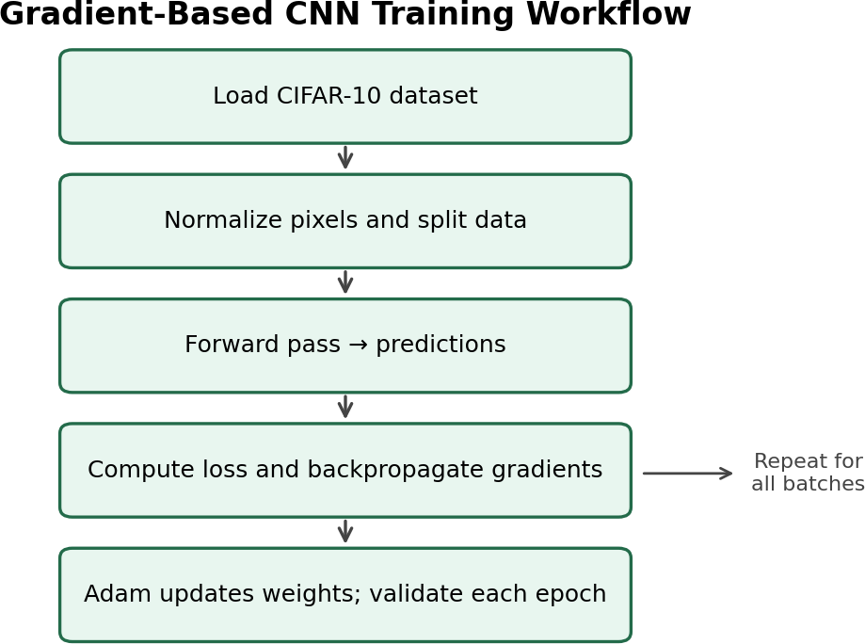

Figure 2. Gradient-based training workflow.

- Normalize pixel values from the range 0–255 to 0–1.
- Use the official training split for fitting and reserve a validation subset from it; keep the test set separate until final evaluation.
- For each mini-batch, perform a forward pass, calculate cross-entropy loss, backpropagate gradients and update weights using Adam.
- Record training and validation loss and accuracy after each epoch.
An epoch is one pass through the training subset. With batch size 64, the number of training steps per epoch is approximately the number of training examples divided by 64, rounded up. The model updates its weights after each mini-batch rather than waiting until the entire dataset has been processed.
The validation subset is used to compare model settings and detect overfitting, not to update weights directly. The test set must be held aside until the final model has been chosen; repeatedly tuning against test results would make the reported test accuracy overly optimistic.
- Evaluate the final selected model once on the held-out test set.

TASK 6 – Explain Gradient-Based Learning
Let θ represent all trainable CNN parameters and L(θ) the loss. Gradient descent updates the parameters in the direction that reduces loss:
θ◻₊₁ = θ◻ − η ∇θ L(θ◻)
Here, η is the learning rate and ∇θL is the gradient of the loss with respect to the parameters. Backpropagation applies the chain rule to calculate these gradients from the output layer towards the earlier layers. Adam modifies this basic update using estimates of the first and second moments of the gradients.
The gradient indicates how a small change in a parameter affects the loss. Backpropagation first computes the error signal at the output and then applies the chain rule layer by layer.
Parameters with gradients are updated, while operations such as max pooling and dropout do not introduce trainable weights.
The learning rate η controls the size of the update. If updates are too large, training may overshoot useful parameter values; if they are too small, convergence can be slow. The training

loss and validation loss curves help identify whether the chosen optimizer settings are working well.

TASK 7 – Training Configuration and Hyperparameters
A reasonable starting configuration is 20 epochs, batch size 64, Adam learning rate 0.001, dropout 0.30 and early stopping with patience 4. The final settings should be adjusted based on validation curves rather than the test set.
The batch size of 64 is a compromise between gradient stability, memory use and the number of updates per epoch. A larger batch can use hardware efficiently but requires more memory; a smaller batch provides more frequent updates but can make gradient estimates noisier.
Early stopping monitors validation loss and restores the weights from the best observed epoch. Patience 4 means training can continue for a few epochs after the last improvement, giving the model a chance to improve before stopping. The number of epochs is therefore a maximum rather than a guarantee that all 20 epochs will run.

TASK 8 – Implement and Test the Model
The following TensorFlow/Keras implementation provides a reproducible baseline. Install the required library with `pip install tensorflow matplotlib` in the Python environment used to run the script.
import tensorflow as tf
from tensorflow.keras import layers, models, initializers import matplotlib.pyplot as plt

# Load CIFAR-10: 50,000 training and 10,000 test images
(x_train, y_train), (x_test, y_test) = tf.keras.datasets.cifar10.load_data() x_train = x_train.astype("float32") / 255.0
x_test = x_test.astype("float32") / 255.0 y_train = y_train.reshape(-1)
y_test = y_test.reshape(-1)

# Use a fixed seed for a more reproducible experiment tf.keras.utils.set_random_seed(42)

model = models.Sequential([ layers.Input(shape=(32, 32, 3)),
layers.Conv2D(32, 3, padding="same", activation="relu", kernel_initializer=initializers.HeNormal()),
layers.MaxPooling2D(pool_size=2, strides=2), layers.Conv2D(64, 3, padding="same", activation="relu",
kernel_initializer=initializers.HeNormal()), layers.MaxPooling2D(pool_size=2, strides=2), layers.Flatten(),
layers.Dropout(0.30),
layers.Dense(10, activation="softmax")
])

model.compile(optimizer=tf.keras.optimizers.Adam(learning_rate=0.001), loss="sparse_categorical_crossentropy",
metrics=["accuracy"]) model.summary()

early_stop = tf.keras.callbacks.EarlyStopping( monitor="val_loss", patience=4, restore_best_weights=True)

history = model.fit(
x_train, y_train, epochs=20, batch_size=64, validation_split=0.1, callbacks=[early_stop], verbose=1)

test_loss, test_acc = model.evaluate(x_test, y_test, verbose=0) print(f"Test loss: {test_loss:.4f}")
print(f"Test accuracy: {test_acc:.4%}")

# Learning curves plt.figure()
plt.plot(history.history["accuracy"], label="Training accuracy") plt.plot(history.history["val_accuracy"], label="Validation accuracy") plt.xlabel("Epoch"); plt.ylabel("Accuracy"); plt.legend() plt.title("CNN Accuracy Learning Curve"); plt.tight_layout() plt.savefig("cnn_accuracy_curve.png", dpi=200); plt.show()

plt.figure()
plt.plot(history.history["loss"], label="Training loss") plt.plot(history.history["val_loss"], label="Validation loss") plt.xlabel("Epoch"); plt.ylabel("Loss"); plt.legend() plt.title("CNN Loss Learning Curve"); plt.tight_layout() plt.savefig("cnn_loss_curve.png", dpi=200); plt.show()

The program prints the layer summary and measured test metrics and saves two learning-curve plots. The exact results depend on the software version, hardware and training run.
Testing procedure: (1) install TensorFlow and Matplotlib, (2) save the code as
`cnn_cifar10.py`, (3) run it from the terminal using `python cnn_cifar10.py`, (4) check the model summary and printed test metrics, and (5) retain the generated plots with the assignment. If installation fails, verify that the selected Python version is supported by the installed TensorFlow release.
For a fair experiment, keep the dataset split, random seed, batch size and optimizer settings fixed when comparing model variants. Record the Python and TensorFlow versions, hardware used, number of epochs completed and final metrics so another student can reproduce the run.
TASK 9 – Report Learning Curves and Test Results
Learning curves are used to understand whether the model is learning and generalizing. Training accuracy should generally rise while training loss falls. Validation curves show whether the improvement transfers to unseen validation images.

Metric / observation | Illustrative report  value | Interpretation
Training accuracy at final  epoch | About 78% | The model fits many training  examples.
Validation accuracy at  best epoch | About 70% | Performance on unseen validation  data.
Test accuracy | About 69% | Final generalization estimate on the  held-out test set.
Training loss | Decreases across  epochs | Optimization is learning useful  features.
Validation loss | Falls, then may  level off | A widening gap can indicate  overfitting.

Important: the percentages above are illustrative values to demonstrate how results should be reported; they are not measured outputs. After running the code, replace these entries with the actual final training accuracy, best validation accuracy, test accuracy and test loss. Insert the generated `cnn_accuracy_curve.png` and `cnn_loss_curve.png` plots here in the submitted version.
When the real run is complete, report the best validation epoch and the corresponding validation accuracy, along with test loss and test accuracy. The final test metrics should come from `model.evaluate(x_test, y_test)` after early stopping has restored the best validation weights.
A healthy learning curve often shows training loss decreasing steadily. Validation loss may decrease more slowly and can eventually rise. If the two curves separate substantially, this suggests overfitting. If both losses remain high, the model may need more training, better preprocessing or a different capacity/learning-rate setting.

TASK 10 – Compare Training Behaviour with Theory
The layer-shape and parameter calculations are deterministic and should match the model summary. Training curves are empirical: their exact values depend on initialization, batch order, hardware and library versions. If training accuracy continues to improve while validation accuracy stalls or validation loss rises, the model may be overfitting. Dropout, augmentation, early stopping or a smaller dense layer can help.
If both training and validation accuracy remain low, the model may be underfitting; possible responses include training longer, adjusting the learning rate or increasing model capacity. A sudden unstable loss can indicate a learning rate that is too high or an input/preprocessing problem.
A small difference between training and validation performance suggests that the model generalizes reasonably well, although both values should be considered alongside the task's target accuracy. A large training–validation gap indicates that the model is fitting the training set better than unseen examples.
Differences between theoretical calculations and practical runtime are expected because parameter counts are exact arithmetic, whereas wall-clock time depends on parallel hardware execution, memory transfers, library optimizations and data-loading overhead. Therefore, use both the layer calculations and measured learning curves to assess the design.

TASK 11 – Recommend and Defend the Final Design
The two-block CNN is a suitable baseline for a small 32 × 32 image-classification task. It uses local convolutional filters to learn edges and textures, pooling to reduce spatial computation, and a compact classifier. Its 60,362 trainable parameters are modest for a learning exercise.
Adam provides a practical optimization starting point, while He initialization and dropout support stable learning and generalization.
The final model should be selected using validation performance, then assessed once on the held-out test set. If higher accuracy is required, test data augmentation, batch normalization, additional convolutional blocks or a modern architecture, while comparing the added computation and parameter count.
The design also offers a clear balance between simplicity and learning capability: convolution layers exploit local spatial structure, max pooling limits feature-map size, and dropout reduces reliance on individual activations. The parameter calculation makes the model's capacity transparent and allows later architectures to be compared objectively.
The model's main limitation is that it is a basic CNN and may not reach the accuracy of deeper residual networks or modern image classifiers. The recommendation is therefore to treat it as a reproducible baseline, retain it when its accuracy and runtime meet the requirement, and increase complexity only when validation evidence supports doing so.

TASK 12 – Re-evaluate the Design for a Larger Dataset
- Impact Analysis
If the dataset becomes much larger or images have higher resolution, the number of convolution operations and memory needed for activations increase. The original 32 × 32 model may not capture enough detail from high-resolution images.
- Evaluate the Original Design
The current CNN remains appropriate for CIFAR-10-sized inputs, but it may become inefficient or underpowered for larger images. Flattening a large feature map also creates a large dense layer, increasing parameter count and overfitting risk.
- Adaptation or Redesign
For larger images, use additional convolutional blocks and global average pooling instead of flattening a large feature map. Consider data pipelines, mini-batch training, augmentation and learning-rate scheduling. For very large datasets, mixed-precision training and GPU acceleration may reduce training time where supported.
- Evidence-Based Defence
The redesign should be justified by measuring training time per epoch, peak memory use, validation performance and test performance. Compare the original and revised models on the same train/validation/test split. Keep the simpler model if it meets the target; adopt the larger design only when measured gains justify its additional cost.
For a larger image dataset, global average pooling is particularly useful because it averages each final feature map into one value rather than flattening every spatial position. This can reduce the number of dense-layer parameters and help limit overfitting. The exact benefit depends on the size and structure of the revised network.
A scalable data pipeline should load and preprocess images efficiently, use shuffling for training, and prefetch batches where supported. If new records arrive continuously, use a documented retraining schedule and monitor class balance and data drift. For the stated image-classification assignment, the redesigned model should be accepted only after a controlled comparison on the same evaluation split.

CONCLUSION
This assignment designed a CNN for CIFAR-10 classification and derived the output shape and parameter count for every layer. He initialization, Adam, dropout and early stopping were selected to support gradient-based training and reduce overfitting. The provided code generates learning curves and actual test results. The final decision should be based on those measured results, not on illustrative values alone.

Key Terms
Convolution: A learnable operation that applies filters to local regions of an input tensor. Stride: The number of pixels by which a filter or pooling window moves at each step.
Padding: Extra border values added around an input to control output dimensions. Initialization: The method used to assign starting values to trainable parameters. Epoch: One complete pass through the training dataset.
Overfitting: When a model fits training data well but performs less effectively on unseen data.

REFERENCES
- Goodfellow, I., Bengio, Y., and Courville, A. Deep Learning. MIT Press, 2016.
- Krizhevsky, A. Learning Multiple Layers of Features from Tiny Images. Technical report, 2009 (CIFAR-10 dataset).
- TensorFlow documentation, Keras Sequential model and CIFAR-10 dataset API: https://www.tensorflow.org/api_docs/python/tf/keras/datasets/cifar10

